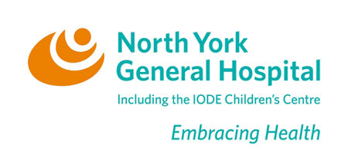
Physician Referral Form for the
Mindfulness-Based Stress Reduction Group (MBSR) at NYGH

This is an OHIP-covered physician-led group, consisting of eight 3-hour sessions, given once a week, on Friday afternoons, in the department of Mental Health. Treatment modalities include gentle yoga, instruction in sitting and walking meditations, the “body scan”, and group discussions about these experiences. There will be an additional 6-hour session on Saturday, in the 6th week, that participants are all expected to attend. About one hour of daily homework will be assigned. This MBSR program is suitable for people with: cancer, arthritis, headaches, irritable bowel, sleep disturbances, fibromyalgia, heart disease, high blood pressure, chronic pain, other chronic medical conditions, and emotional distress. (Exclusion criteria include substance abuse or dependence, and acute or active mental illness.) There is a $120.00 fee to cover the cost of materials (books, CDs, etc.) For further information, please see www.mydoctor.ca/mbsr If you have any patients who you believe may benefit from this program, please fax your referrals to NYGH Intake at: 416-756-6671, * and have your patients call Dr. Kathy Margittai at 416-483-3778 to register.

Patient Name
Date of Birth
Gender
Address
Home Phone
Work Phone
HC #
List all medical conditions please:
Medications:
Allergies:
*Referring MD
Specialty
Office Address
Ref. Phone #
Ref. Fax #
OHIP ref.#
Date of referral | Signed

01 / 2011

